**ECOMMERSE SPA**

**Introduction**

**1.1 Overview**

The e-commerce SPA (Single Page Application) project is a web application developed using PHP 8.3.3 and the Laravel framework version 11.0.6. It provides a platform for users to browse, select, and purchase products online in a seamless and intuitive manner.

**1.2 Purpose**

The purpose of this project is to create a modern and user-friendly e-commerce platform that offers a rich shopping experience to customers. By leveraging the capabilities of Laravel and PHP, the application aims to provide robust functionality for product management, cart management, secure payment processing, and order management.

**1.3 Objectives**

The key objectives of the e-commerce SPA project include:

* Develop a responsive and interactive web application for online shopping.
* Implement features such as product browsing, cart management, and checkout process.
* Integrate PayPal Sandbox for secure payment processing.
* Ensure high performance, scalability, and security of the application.
* Provide comprehensive documentation for developers, administrators, and users.

**1.4 Technologies Used**

The main technologies and tools used in the project are:

* **PHP 8.3.3**: The server-side scripting language used for backend development.
* **Laravel 11.0.6**: The PHP framework for building web applications.
* **MySQL**: The relational database management system for storing application data.
* **JavaScript/jQuery**: Used for client-side scripting and enhancing user interactions.
* **HTML5/CSS3**: Standard markup and styling languages for building web pages.
* **Bootstrap**: Frontend framework for responsive and mobile-first web development.
* **PayPal Sandbox**: Development environment for testing PayPal payment integration.

**Server and database setup threw docker:**

**Note:Using Docker** for server and mysql setup,there is a **docker.compose.yml** file in the root directory of the project,please open a command prompt with Laravel root directory and run command **docker compose up** for server and database setup.

**Sql scripts:**

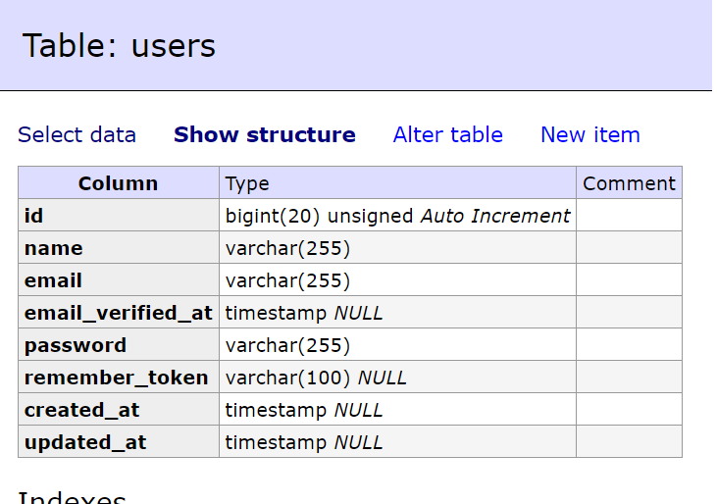

**INSERT INTO `users` (`id`, `name`, `email`, `email_verified_at`, `password`, `remember_token`, `created_at`, `updated_at`) VALUES**

**(1, 'Bernadine Stanton ', 'bprice@example.com', '2024-03-15 15:28:37', '$2y$12$YF9vQ1hXvVHUUx78EzZRsOaTvZVeW0Fg3IItQLyQbOHn/kVR8pl1S', 'LbOwJgpIWi', '2024-03-15 15:28:38', '2024-03-15 15:28:38'),**

**(2, 'Reilly Donnelly', 'liam.padberg@example.net', '2024-03-15 15:28:38', '$2y$12$YF9vQ1hXvVHUUx78EzZRsOaTvZVeW0Fg3IItQLyQbOHn/kVR8pl1S', 'JBe9vfBvKk', '2024-03-15 15:28:38', '2024-03-15 15:28:38');**

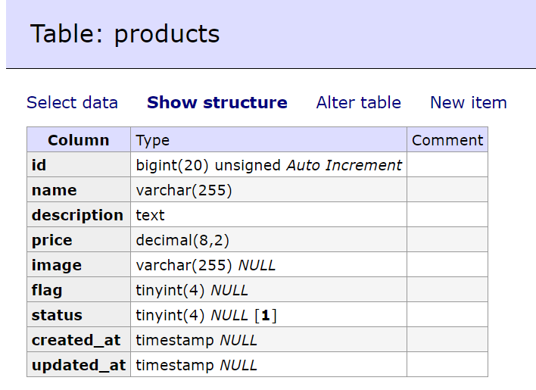

**INSERT INTO `products` (`id`, `name`, `description`, `price`, `image`, `flag`, `status`, `created_at`, `updated_at`) VALUES**

**(1, 'Tomatoes', 'Laudantium nemo rerum voluptatem.', 5.26, 'http://127.0.0.1:8000/img/vegetable-item-1.jpg', 1, 1, '2024-03-15 15:28:38', '2024-03-15 15:28:38'),**

**(2, 'Cauliflour', 'Fugiat doloremque animi dolor aut itaque qui quia et.', 4.51, 'http://127.0.0.1:8000/img/vegetable-item-2.jpg', 1, 1, '2024-03-15 15:28:38', '2024-03-15 15:28:38'),**

**(3, 'Potatoes', 'Dignissimos voluptates adipisci ut dolorem voluptates ducimus.', 9.05, 'http://127.0.0.1:8000/img/vegetable-item-5.jpg', 1, 1, '2024-03-15 15:28:38', '2024-03-15 15:28:38'),**

**(4, 'Coriander Leafs', 'Incidunt quae repellendus sit dolores nihil eius.', 5.29, 'http://127.0.0.1:8000/img/vegetable-item-6.jpg', 1, 1, '2024-03-15 15:28:38', '2024-03-15 15:28:38'),**

**(5, 'Oranges', 'Nemo veritatis recusandae maiores nostrum.', 7.05, 'http://127.0.0.1:8000/img/fruite-item-1.jpg', 2, 1, '2024-03-15 15:28:38', '2024-03-15 15:28:38'),**

**(6, 'Cherry', 'Velit magni molestias saepe.', 4.13, 'http://127.0.0.1:8000/img/fruite-item-2.jpg', 2, 1, '2024-03-15 15:28:38', '2024-03-15 15:28:38'),**

**(7, 'Bananas', 'Accusantium expedita est nisi.', 5.06, 'http://127.0.0.1:8000/img/fruite-item-3.jpg', 2, 1, '2024-03-15 15:28:38', '2024-03-15 15:28:38'),**

**(8, 'Rasberries', 'Quasi repellendus reiciendis sit et.', 2.98, 'http://127.0.0.1:8000/img/fruite-item-4.jpg', 2, 1, '2024-03-15 15:28:38', '2024-03-15 15:28:38'),**

**(9, 'Grapes', 'Et iusto id in.', 8.31, 'http://127.0.0.1:8000/img/fruite-item-5.jpg', 2, 1, '2024-03-15 15:28:38', '2024-03-15 15:28:38'),**

**(10, 'Apple', 'Ut tenetur in cupiditate corporis similique vel dicta.', 3.24, 'http://127.0.0.1:8000/img/fruite-item-6.jpg', 2, 1, '2024-03-15 15:28:38', '2024-03-15 15:28:38'),**

**(11, 'Organic Oranges', 'Est sit sed nulla eveniet est.', 4.26, 'http://127.0.0.1:8000/img/best-product-1.jpg', 3, 1, '2024-03-15 15:28:38', '2024-03-15 15:28:38'),**

**(12, 'Organic Cherries', 'In nihil quia accusantium velit velit distinctio veritatis.', 5.11, 'http://127.0.0.1:8000/img/best-product-2.jpg', 3, 1, '2024-03-15 15:28:38', '2024-03-15 15:28:38'),**

**(13, 'Organic Bananas', 'Quaerat ut dolores tempore.', 8.25, 'http://127.0.0.1:8000/img/best-product-3.jpg', 3, 1, '2024-03-15 15:28:38', '2024-03-15 15:28:38'),**

**(14, 'Organic Rasberries', 'Recusandae itaque quaerat vero.', 9.32, 'http://127.0.0.1:8000/img/best-product-4.jpg', 3, 1, '2024-03-15 15:28:38', '2024-03-15 15:28:38'),**

**(15, 'Organic Grapes', 'Voluptate autem atque eum vitae id praesentium.', 4.74, 'http://127.0.0.1:8000/img/best-product-5.jpg', 3, 1, '2024-03-15 15:28:38', '2024-03-15 15:28:38'),**

**(16, 'Organic Apples', 'Adipisci et maxime consequatur ut ullam rerum.', 3.94, 'http://127.0.0.1:8000/img/best-product-6.jpg', 3, 1, '2024-03-15 15:28:38', '2024-03-15 15:28:38');**

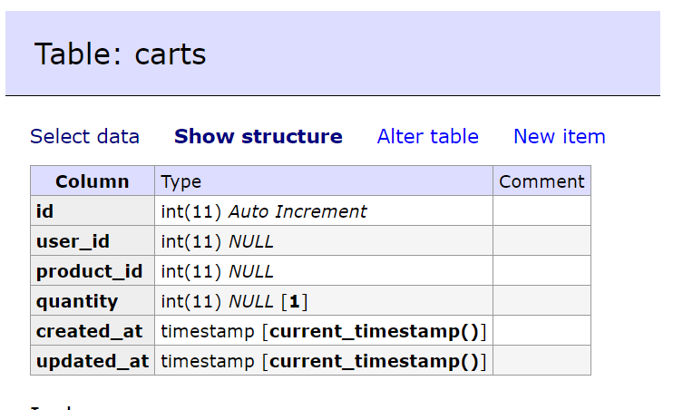

**INSERT INTO `carts` (`id`, `user_id`, `product_id`, `quantity`, `created_at`, `updated_at`) VALUES**

**(1, 2, 1, 1, '2024-03-16 14:02:16', '2024-03-16 14:03:59'),**

**(3, 1, 3, 1, '2024-03-16 14:30:01', '2024-03-16 14:30:01'),**

**(4, 1, 4, 1, '2024-03-16 14:31:06', '2024-03-16 14:31:06'),**

**(5, 1, 6, 2, '2024-03-16 14:35:41', '2024-03-16 16:54:33');**

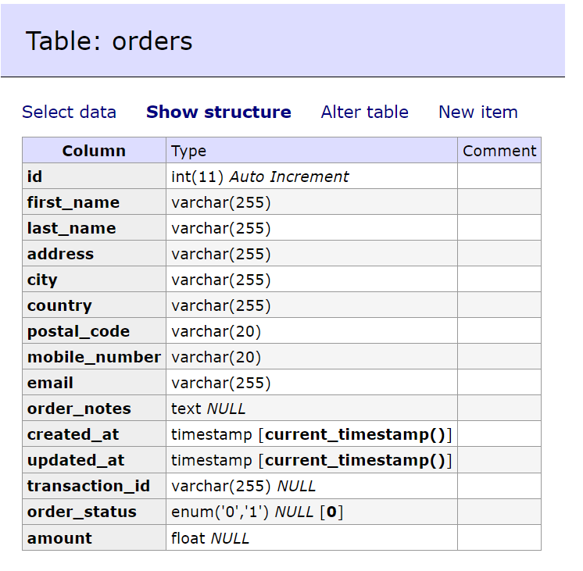

**INSERT INTO `orders` (`id`, `first_name`, `last_name`, `address`, `city`, `country`, `postal_code`, `mobile_number`, `email`, `order_notes`, `created_at`, `updated_at`, `transaction_id`, `order_status`, `amount`) VALUES**

**(1, 'Vikas', 'Pandey', 'Serampore Hooghly', 'Kolkata', 'India', '712202', '8910599783', 'starvikass@gmail.com', 'want the order urgently', '2024-03-17 12:17:21', '2024-03-17 12:19:27', 'TXN123456789', '1', 22.6);**

**SCREENSHOTS:**

**Home Page:**

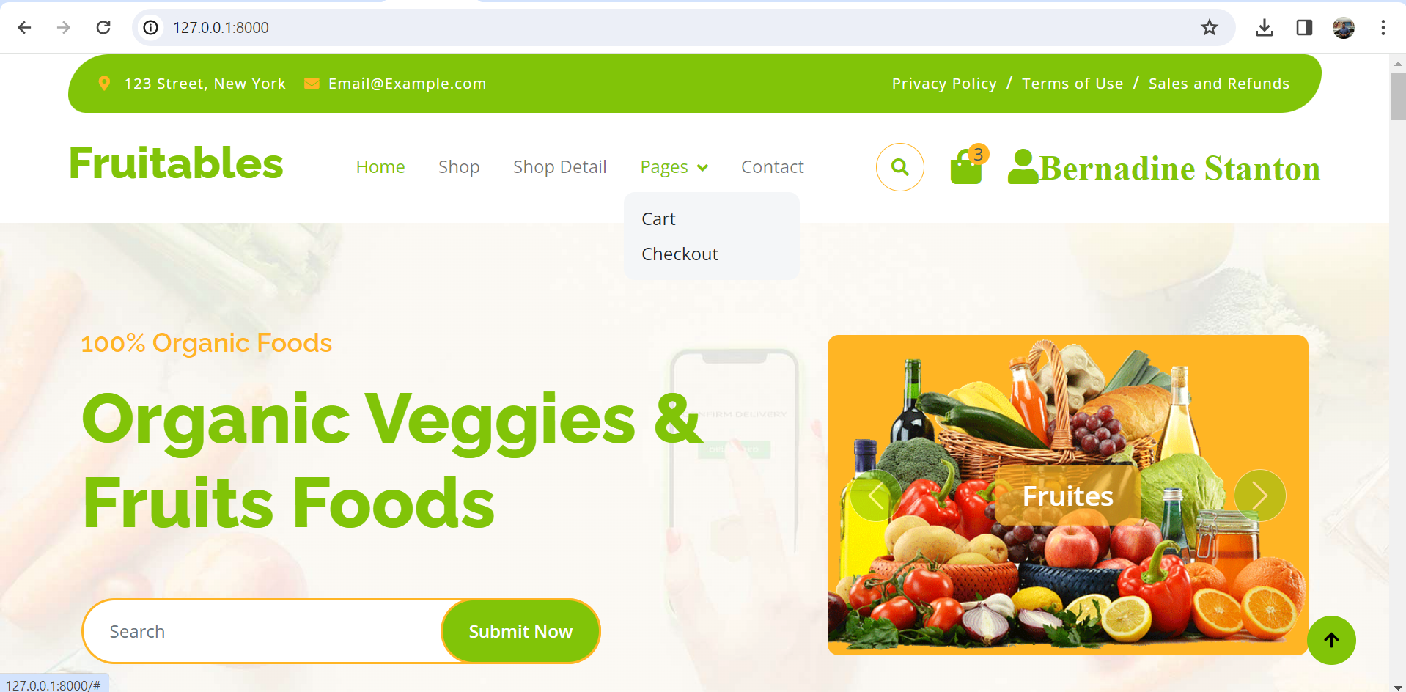

**Cart Part:**

**Checkout Part:**

**Commands**

**1.To run the project: php artisan serve**

**2.Models with migration:**

**a.php artisan make:model Product --m**

**b. php artisan make: model Cart --m**

**c. php artisan make: model Order --m**

**3.Make controllers:**

**a.php artisan make: controller ProductController**

**b.php artisan make: controller CartController**

**c.php artisan make: OrderController**

**php artisan migrate: refresh –seed**

Note:This command will delete the old data and populate the database tables .

**Conclusion:**

The scope of the project includes:

* Creating a user-friendly interface for browsing products by category, price, etc.
* Implementing a shopping cart system to add, remove, and update selected items.
* Integrating secure payment processing using PayPal Sandbox.
* Allowing users to create accounts, login, and manage their profiles.
* Generating order invoices and sending email notifications to customers.